

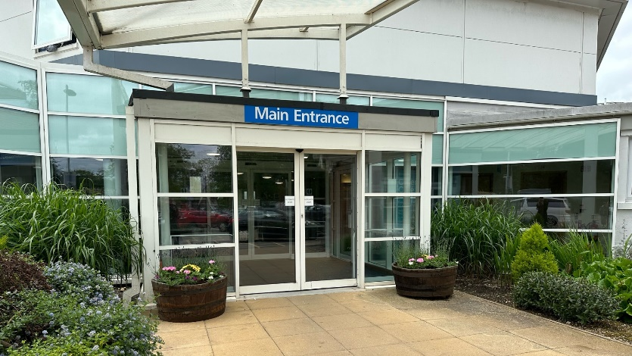

Cotswold House specialist eating disorders

Guidance for family and friends in supporting someone with an eating disorder

Contents

Introduction 3

Helpful and less helpful interactions 3

The things you say 4

Rephrasing 6

Thank you to our patients and families 7

Accessibility 8

Get in touch 8

Feedback 8

# Introduction

‘One of the most important things to remember is I’m still me’

‘Although I may be struggling with an eating disorder now, engaging with me and learning my strengths will help me on the path to recovery’

It can be very scary when our loved one is struggling with an eating disorder.

We want to help but sometimes don’t know how to do this in the best way. But it’s important to remember that our role as carers is extremely important and valuable.

This leaflet has been designed to offer some tips that may be helpful in interacting with a loved one who is struggling with an eating disorder.

# Helpful and less helpful interactions

At the end of this leaflet, you will find a list of helpful and unhelpful approaches that have been adapted from feedback given by patients, taken from their own personal experience.

This is not an exhaustive list, but it might give an idea about areas to be mindful of and how we can be supportive.

We found that comments relating to ‘food’ and ‘physical appearance’ were particularly sensitive. ‘Trust’ was also identified as being important.

It might be a good idea to give your loved one a copy of this list and ask them to highlight points that they relate to, or think would be helpful.

Depending on where we are on our recovery journey, our needs and the level of support will change. It may change depending on our mood, so maintaining communication is important.

# The things you say

We have also made some suggestions about comments that might be difficult to hear for someone with an eating disorder, and some alternatives that we can use.

## Helpful

* Staying calm and level-headed
* Safe space to initiate uncomfortable conversations- allow us to initiate conversation if it’s about treatment/ wellbeing.
* Check in via text before making phone call- may not always feel up for chatting.
* Making plans can be helpful but not too far into the future- unless conversation is led by us.
* Support if needed- not adding pressure.
* Playing games/ quiz/ watching program/ interactive but not treatment focused.
* Hearing about other people’s days in general, talking about work/ home life/ DIY/ pets.
* Writing letters- allows time to reflect and also doesn’t involve discussing treatment conversations.
* Knowing that you are loved and supported.
* Understanding/ trying to gain an understanding of what is happening and why treatment may look different to previous treatments/ meal plan/ portion sizes / challenges.

## Not so helpful

* Comment on appearance- including body shape/ weight/clothing fitting.
* Repeating advice/ pushing same advice when facing resistance – ‘you should try…it works for/ helps me’
* Considered/ treated as unable to make appropriate choices- allow us to prove we can change through treatment.
* Referring to old habits, ‘expecting’ a slip up and taking control from start.
* Lack of understanding in the process- weight restoration doesn’t equal recovery- long way to go after discharge.
* Not accepting that recovery may not be what they want at the current time.
* Talking about treatment, weight restoration/loss, meals and meal plans.
* Labelling foods ‘good’ and ‘bad’- understanding nutrition and that fad diets do not work or discussing what you have or haven’t had to eat that day.
* Trying to coax conversations around treatment (to gain a better understanding)

# Rephrasing

* ‘You look better/healthier/put on weight/different/pretty’ ­‘it’s nice to see you/spend time with you.’ or ‘we value you as a person’- sometimes the ED can fish for ‘insults’ to gain back control.
* ‘When are you going to be fixed/recovered/normal?’- this can put immense pressure on a decision to ‘recover’ and that decision may not have been or want to be made. ‘How are you getting on with your goals this week?’ ‘Shall we make a plan for home leave/ day visit/ time out?
* Trust can be hard when you have not witnessed the process. ‘Is that the right amount? do you have to eat all of that? ‘Try not to comment on portion sizes instead prior to meals have a discussion around how to support if wanted/needed. Perhaps share the food diary to get a better understanding and if able take a step back ‘would it be helpful if I had my meal/snack now too?’

# Thank you to our patients and families

This leaflet was co-produced by patients on the ward.

# Accessibility

Patient information leaflets are available on our website: www.oxfordhealth.nhs.uk/leaflets

# Get in touch

Address Oxford Health NHS Foundation Trust

Trust Headquarters

Littlemore Mental Health Centre  
Sandford Road, Oxford OX4 4XN

Phone 01865 901 000

Email enquiries@oxfordhealth.nhs.uk

Website www.oxfordhealth.nhs.uk

# Feedback

Our Patient Advice and Liaison Service (PALS) provides advice and support to patients, families, and carers, helping to resolve any problems, concerns, or complaints you may have.

Phone 0800 328 7971

Email PALS@oxfordhealth.nhs.uk

Become a member of our foundation trust: www.ohftnhs.uk/membership

Support Oxford Health Charity, making a difference to patients, their families and staff who care for them: www.oxfordhealth.charity