Regent House- Aylesbury
There is no parking available at the site. The nearest car parks are as follows:
- Friars Square Multi-story Car Park, HP20 1RU- 6 minute walk, Cash/Card
- Waterside North Car Park, HP20 1UG - 6 minute walk, Cash/Card/Ringo
- Exchange street car park, HP20 1QY - 8 minute walk, Cash/Card/Ringo

- Accessible Parking: There are up to 5 blue badge spaces available directly outside the building. There is also free blue badge parking available on Kingsbury Street (60m away)

- There is drop off space available outside the building

Address:
Regent House Business Centre, 13-15 George Street, Aylesbury, HP20 2HU
Access to the building is via George Street
On arrival, please press the buzzer labelled for Buckinghamshire Talking Therapies/Primary Care Mental Health. Once in the building you will be met by the team’s receptionist who will show you to the waiting room.

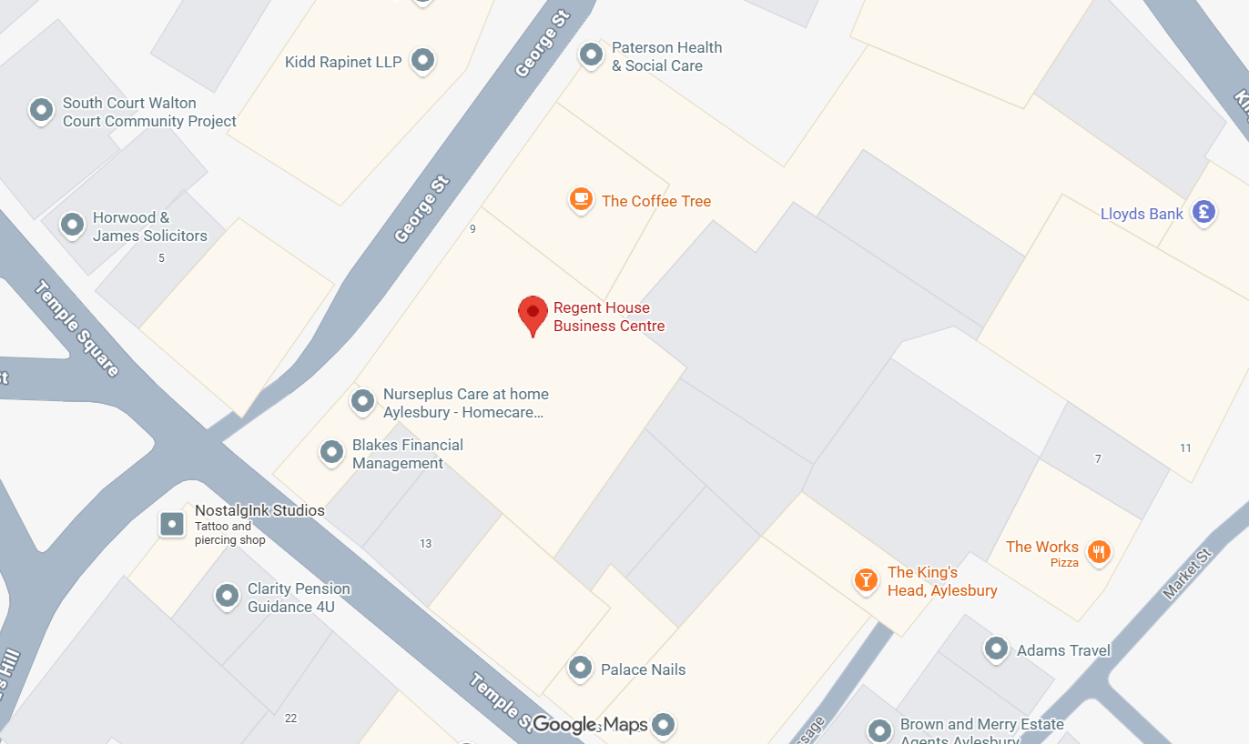
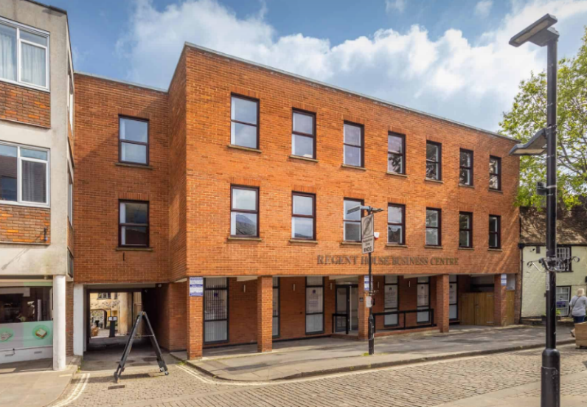
What.3.words: port.twig.tinsel
Contact: 01865 901600 (Bucks Talking Therapies)
Bucks-talking-therapies@oxfordhealth.nhs.uk

