The Whiteleaf Centre
Peach Tree House
Oxford Health NHS Foundation Trust
Bierton Road
Aylesbury
Bucks
HP20 1EG

Please note – Peach Tree House is the building to the right of the main Whiteleaf Building.
Clinic rooms are on the ground floor and there is good disabled access and a disabled access toilet.
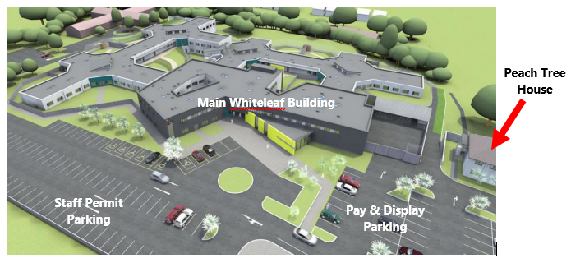

CAR PARKING CHARGES

Please be advised that there are now parking charges in force at The Whiteleaf Centre. The charges are as follows:

Up to 30 minutes | Free
Up to 1.5 hours | £1.00
Up to 2.5 hours | £2.00
Up to 3.5 hours | £3.00
Over 3.5 hours | £4.00

Please make sure you have change available as there are parking attendants in force and will issue parking tickets.

