Saffron House
NHS South Bucks Mental Health Hub
St John’s Place
Easton Street
High Wycombe
HP11 1NH

Access by Foot or Bike
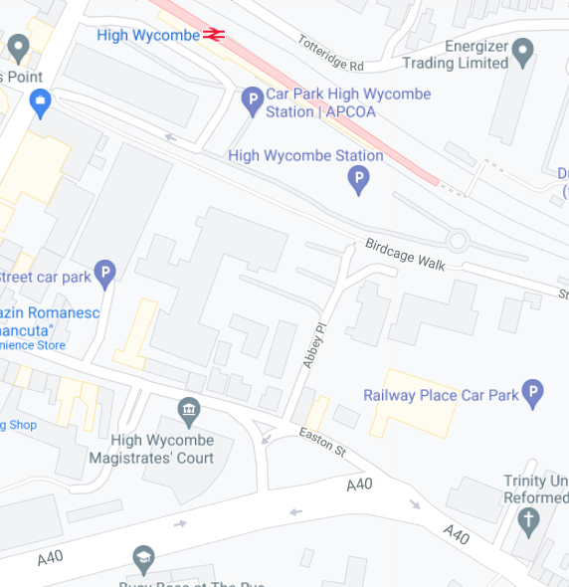
From the A40 turn off the at the pedestrian lights by Trinity Church to walk up to Railway Place Car Park and go through the gate to Saffron House as pointed out above
This is the Main Entrance to Saffron House
This building is Saffron House
From High Wycombe Railway Station walk along Birdcage Walk to Railway Place Car Park and go through the gate along here

Access by Car & Parking Information here is a Google Maps link to Railway Place Car Park
2. This is Railway Place Car Park where patients who are driving should park
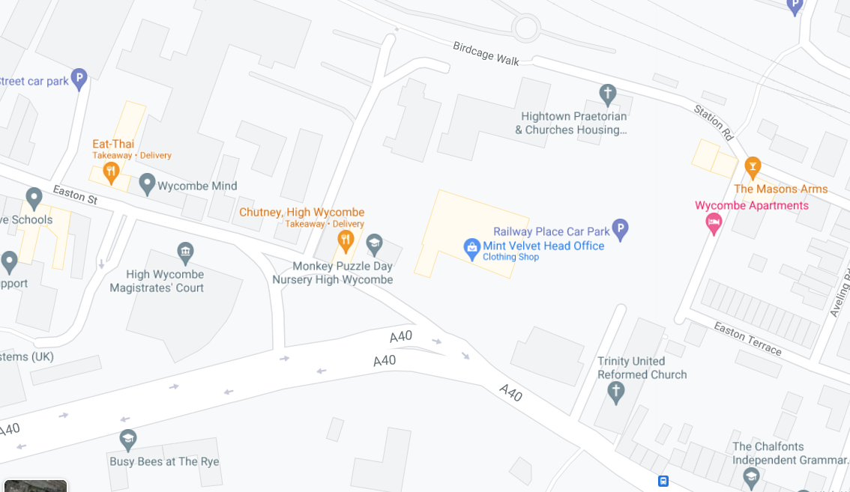
3. To walk from Railway Place Car Park to Saffron House go through the gate along here
1. To drive to Railway Place Car Park turn off the A40 at the pedestrian lights by Trinity Church
This building is Saffron House

This is the Main Entrance to Saffron House

Railway Place Car Park is where we recommend patients park if they are driving to Saffron House. Here is information about Railway Place Car Park – please note this is not the Station Car Park. It is also conveniently located opposite The Rye which is a lovely green space you could explore after your visit to Oxford Health.

If you wish to park elsewhere here is information about High Wycombe car parks.

