

**Floor sitting**

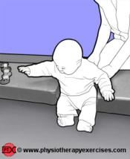 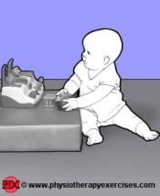 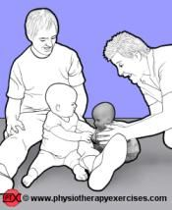

Why your sitting position is important

* Children need to learn how to sit symmetrically
* Sitting develops strength of antigravity muscles of the head and trunk
* Children learn to develop balance by being placed in sitting
* To see the world from an upright position

What to check for

* Symmetry or at least being able to return to a symmetrical position – once you can be symmetrical then a child learns how to be asymmetrical
* Avoid w sitting or legs rolling inwards
* 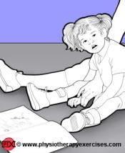Understand what positon your physiotherapist would like you to use and what to avoid
* Offer support where and when needed

Different sitting positons

Long sitting – legs out straight in front. This is good for maintaining the length of the hamstrings muscles but often children cannot tolerate for long periods of time

Cross legged sitting – hips apart and legs crossed at ankles

Side sitting – check which side your physiotherapist suggests

How to progress

* 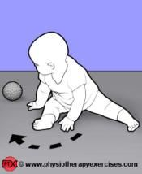Reaching in all directions
* Pivoting
* Moving from sitting to 4 point kneel