Core Vocabulary

The Speech and Language Therapist who is supporting your child may recommend core vocabulary if they feel that it is right for them. If so, they will provide you with the specific resources needed, and carefully selected targets for them to work towards. They will also aim to demonstrate these activities to you or a member of staff at your child’s school.

A record form to help with motivation, can be found at the end of the leaflet. Like learning any new skill, such as a language or a musical instrument, there is evidence showing that practising little and often is key to supporting your child to learn this new skill. Your child’s Speech Therapist will advise you how frequently to complete the activities.

What is Core Vocabulary?

Core Vocabulary is a therapy program designed by Speech and Language Therapists to help children improve the clarity of their speech. It focuses on words that have been specifically selected for each individual. These words will be functionally powerful for the child and will usually be used most days within natural conversation. For example, they often include names of family, friends and pets or favourite items such as food, colours, animals and toys.

Who is it for?

Core Vocabulary is recommended for children who have a disorder of speech. This means that their speech sound system is developing differently to their peers. It’s used with a wide range of different age groups but does require adequate attention and listening skills. It is most useful for children who are making inconsistent errors. This means that they may have several ways of pronouncing the same word or sound*.* For example, when saying “help” it may sound like “hap” one day and “elp” the next, or they may be able to use ‘s’ at the beginning of “**s**eat” but not “**s**ay”.

How does it work?

Core Vocabulary starts by supporting the child to make their “best production” or their key words, using a variety of cues including:

* Breaking words into syllables
* Verbal descriptions
* Visual prompts such as gestures and drawings

The sessions then involve lots of repetitions of the newly learned words and feedback is provided by the adult. The primary aim is for the child to say the words exactly the same way each time, rather than saying them perfectly. New words are added to the list as and when the child makes progress.

What do I need?

* A list of motivational words to focus on
* Visuals to represent these words e.g. drawings that your child has made
* A bag/folder to keep the words in
* A visual to help with counting e.g. a dice or a picture of a ladder
* Quick motivational games to be used as rewards e.g. Lego

What do I do?

* Put 10 of your child’s words into a bag and let them choose one at random
* Listen carefully for any sounds they’re finding difficult; they may be missing them out or replacing them with other sounds
* Support your child to be able to say each sound, using the cues demonstrated by their Speech and Language Therapist. This may include splitting the word into its separate syllables, using picture cards and gestures, writing the letters down and describing how the sounds are made
* Make a note of their best attempt, and then repeat this process with all 10 words.

|  |  |  |
| --- | --- | --- |
|  | **Target Word** | **Best Production**  *\*This is the production we are aiming for them to make consistently instead of the target word\** |
| 1 |  |  |
| 2 |  |  |
| 3 |  |  |
| 4 |  |  |
| 5 |  |  |
| 6 |  |  |
| 7 |  |  |
| 8 |  |  |
| 9 |  |  |
| 10 |  |  |

* Play fun games that requires your child to repeat each word 10 times. This could be as simple as letting your child walk a toy animal up a ladder picture whilst they say the words, or winning swords for Pop-Up Pirate in return for each attempt.

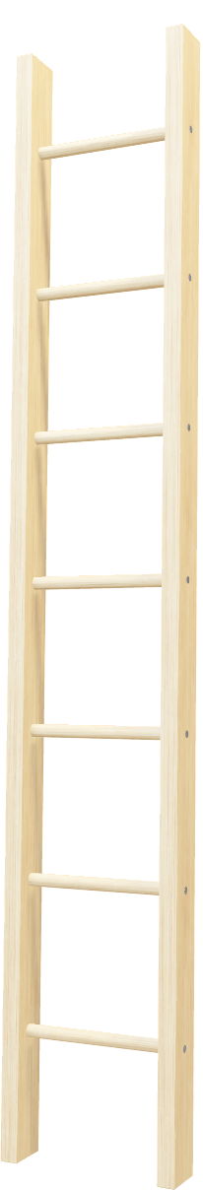

* At the end of the session, ask your child to repeat the key words 3 times. Keep a note of what these 3 attempts sound like. The Speech and Language Therapist will need this to track progress and decide when it is time to choose some new words.

|  |  |  |  |  |
| --- | --- | --- | --- | --- |
| **Date** | **Target** | **1st Attempt** | **2nd Attempt** | **3rd Attempt** |
|  | 1.  2.  3.  4.  5.  6.  7.  8.  9.  10. | 1.  2.  3.  4.  5.  6.  7.  8.  9.  10. | 1.  2.  3.  4.  5.  6.  7.  8.  9.  10. | 1.  2.  3.  4.  5.  6.  7.  8.  9.  10. |
|  | 1.  2.  3.  4.  5.  6.  7.  8.  9.  10. | 1.  2.  3.  4.  5.  6.  7.  8.  9.  10. | 1.  2.  3.  4.  5.  6.  7.  8.  9.  10. | 1.  2.  3.  4.  5.  6.  7.  8.  9.  10. |

**My Record Sheet**

I will practice ____ times a week.

My reward will be _____________________

|  |  |  |  |  |  |  |
| --- | --- | --- | --- | --- | --- | --- |
| **Monday** | **Tuesday** | **Wednesday** | **Thursday** | **Friday** | **Saturday** | **Sunday** |
| C:\Users\amy.carter\AppData\Local\Microsoft\Windows\INetCache\Content.MSO\5E8934CF.tmp | C:\Users\amy.carter\AppData\Local\Microsoft\Windows\INetCache\Content.MSO\DDEFA6B5.tmp | C:\Users\amy.carter\AppData\Local\Microsoft\Windows\INetCache\Content.MSO\5DCF7F8B.tmp | C:\Users\amy.carter\AppData\Local\Microsoft\Windows\INetCache\Content.MSO\E3528CD1.tmp | C:\Users\amy.carter\AppData\Local\Microsoft\Windows\INetCache\Content.MSO\F971A43.tmp | C:\Users\amy.carter\AppData\Local\Microsoft\Windows\INetCache\Content.MSO\ED3626AD.tmp | C:\Users\amy.carter\AppData\Local\Microsoft\Windows\INetCache\Content.MSO\50EB7807.tmp |