

Transitions—moving from the highly structured, social, and sensory-demanding environment of school or college to the less structured, "safe" environment of home—can be one of the most common and challenging difficulties. Let's turn this into an exercise for you, focusing on understanding "why" it's hard and then building a practical toolkit to make it smoother.

Exercise: Decoding the School/College-to-Home Transition
We're going to investigate why the journey can feel so tricky and then create a personalised plan to make it better.

Part 1: The 'Why?' - Understanding Your Brain's Journey

Imagine your brain is a powerful computer. Throughout the school day, you've had dozens of different programs and tabs open.

- Autism Tab: Managing social rules, filtering out bright lights and loud noises, sticking to a routine, understanding what teachers mean.
- ADHD Tab: Trying to focus, resisting distractions, controlling impulses, remembering instructions, managing time.
- And of course, all your school or college subjects:
- Academic Tabs: Maths, English, Science, History... all running at once.

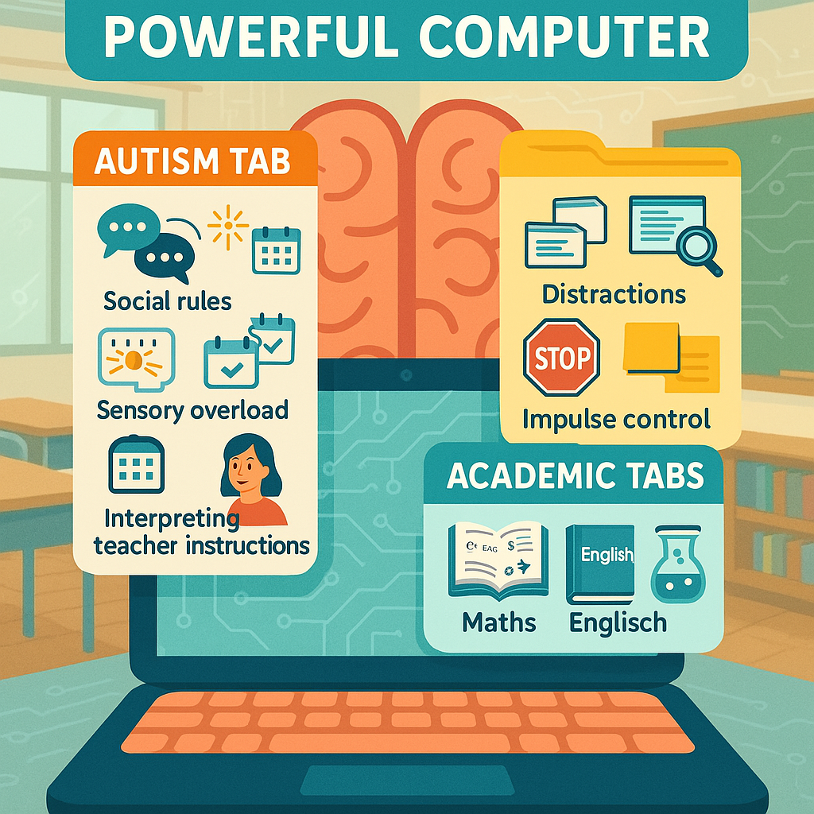

When the final bell rings, it's not as simple as just shutting down your computer. It's more like the power has been suddenly unplugged. The programs all crash at once, and it takes time to restart.
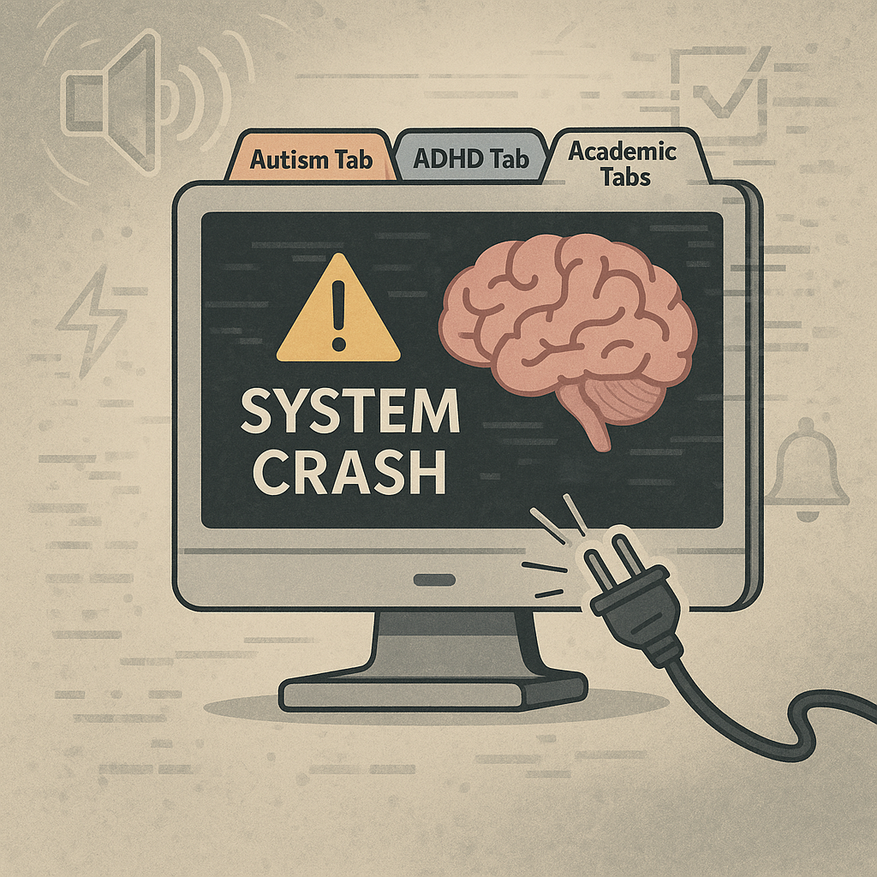

Let's explore what's happening during this "crash and restart" phase:

- The Energy Drain (The 'Social Battery')

Think of your energy for dealing with people and tasks as a phone battery.
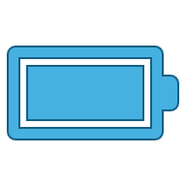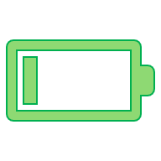

Throughout the day: Every conversation, every instruction you follow, every time you have to ignore a distracting noise, it uses up a little bit of battery.

- For brains with autism and ADHD, this happens much faster.
- When the bell rings: Your battery is probably on 1% and flashing red. You have no energy left for more demands, like talking about your day or doing homework.
- This can lead to what's sometimes called "after-school restraint collapse"—holding it all together all day and then melting down in your safe space (home).
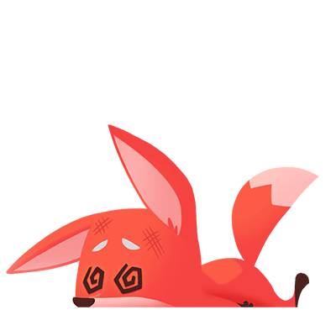

2. The Gear Shift (Changing Environments)
Going from school to home is a huge "gear shift" for your brain.
- School Mode: Loud, bright, fast-paced, lots of rules, very structured.
- Home Mode: (Hopefully) Quieter, calmer, less structured, different expectations.
This shift is jarring. It's like being teleported from a noisy rock concert straight into a quiet library. Your senses and brain need time to adjust. A brain that loves predictability (autism) and struggles to switch tasks (ADHD) finds this sudden, total change very difficult to process.
3. The Executive Function 'Holiday'
Your brain's "manager" is your executive function. It handles planning, organising, and starting tasks.
- At school: The timetable, the teachers, and the bells are doing a lot of that manager's job for you. They tell you where to be and when.
- At home: Suddenly, you have to be your own manager again. "What should I do first? Where do I put my bag? I'm supposed to do homework, but I need to relax. What am I meant to be doing right now?"
- When your brain is already tired, the manager just goes on holiday, making these simple decisions feel impossible.
- 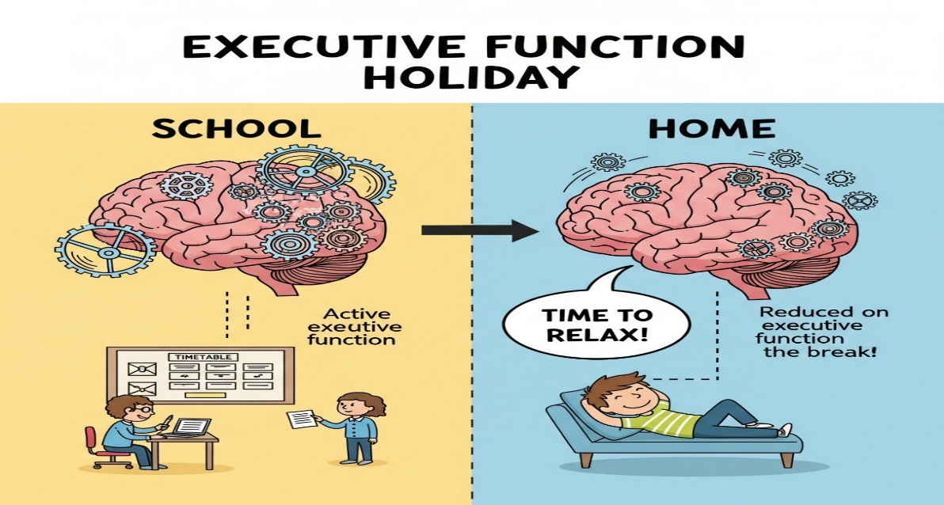

Part 2: The 'How?' - Building Your Transition Toolkit

Now that we know why it's hard, we can build a personalised toolkit to help your brain make the journey smoothly. Pick and choose the tools you think will work for you.
Tool #1: The 'Power-Down Sequence' (Before Leaving School)
This is about giving your brain a warning that the "School" program is about to close.
- 5-Minute Alarm: Set a quiet, vibrating alarm on a watch or phone for 5 minutes before the final bell. When it goes off, it's your personal signal to start the power-down sequence.
- The Pack-Up Checklist: Have a small, physical checklist on a card or on your phone.
- [ ] Planner/Homework
- [ ] Water Bottle
- [ ] Jumper/Coat
- [ ] House Keys
- This stops the last-minute panic and uses a visual guide, which is great for both autism and ADHD.
- A 'Goodbye' Ritual: Do the same small thing each day. Maybe it's a quick wave to a specific teacher, tapping the doorframe as you leave, or saying "See you tomorrow" to a friend. This creates a clear, predictable end to the school day.

Tool #2: The 'Travel Bubble' (The Journey Home)

The journey itself is the transition. Your job here is to protect your 1% battery and let your brain adjust.
- Sensory Blockers:
- Headphones/Earbuds: Essential. Listen to music, a podcast, or just use noise-cancelling to block out the world. This is your "Do Not Disturb" sign for your brain.
- Sunglasses/Cap: If the light is too bright, block it out. Reduce the amount of information your brain has to process.
- Fidget Item: Have a specific, approved fidget toy just for the journey. This gives your restless ADHD energy a quiet place to go.
- The 'No Questions' Rule: This is a rule you can agree with your parent or carer. For the first 15-20 minutes of the journey, there are no questions about your day. You can volunteer information if you want, but you are not expected to talk. A simple "Hi" is enough.
- A Predictable Snack: Have a small, specific snack and drink for the journey home. Low blood sugar makes emotional regulation much harder. This provides a sensory comfort and a small energy boost.
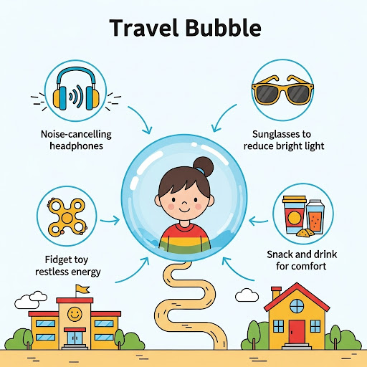

Tool #3: The 'Landing Pad' (Arriving at Home)
You've landed. Now you need to get from the front door to your safe space without crashing.
- The Drop Zone: Have one specific place right by the door where your bag, shoes, and coat go. Every single time. This removes the "What do I do with my stuff?" decision. A labelled box or a specific hook works wonders.
- The Decompression Chamber: This is the most important tool. You need a planned period of zero-demand decompression. This is non-negotiable recovery time. Agree on this with your family.
- Duration: It could be 30 minutes; it could be an hour.
- Activity: This must be something that recharges your battery, not drains it more.
- Lying in your room with a weighted blanket.
- Listening to your favourite album.
- Watching a specific YouTube channel.
- Stroking a pet.
- Using a sensory toy (like slime or a stress ball).
- Crucially, this is NOT: Screen time that is highly stimulating (like a fast-paced video game) or scrolling social media, as these can sometimes drain the battery more. It needs to be calming.
- The 'Ready' Signal: After your decompression time is up, you need a low-effort way to signal to your family that you're ready to interact. This could be coming out of your room, sending a text, or giving a thumbs-up. This puts you in control
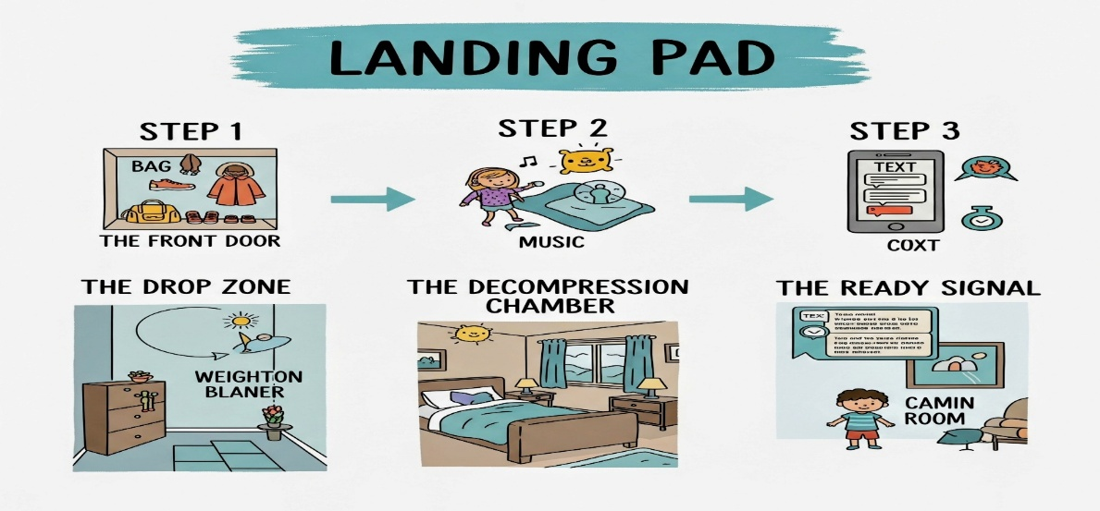

Your Mission: Create Your Personal Transition Plan

Fill this out to make your plan official.
My Power-Down Sequence (at school or college):
- My 5-min warning will be: _________________
- My 'Goodbye' ritual will be: _________________
My Travel Bubble (the journey):
- My headphones choice: _________________
- My fidget item: _________________
- My travel snack/drink: _________________
My Landing Pad (at home):
- My Drop Zone is: _________________
- My Decompression Time will be for ______ minutes.
- My chosen decompression activity is: _________________
- My 'Ready' Signal will be: _________________

By understanding why this is hard and creating a predictable routine with sensory tools, you're not just trying to survive the journey from school or college to home. You're giving your brain the respect and support it needs to make the transition successfully.
Caring, safe and excellent

