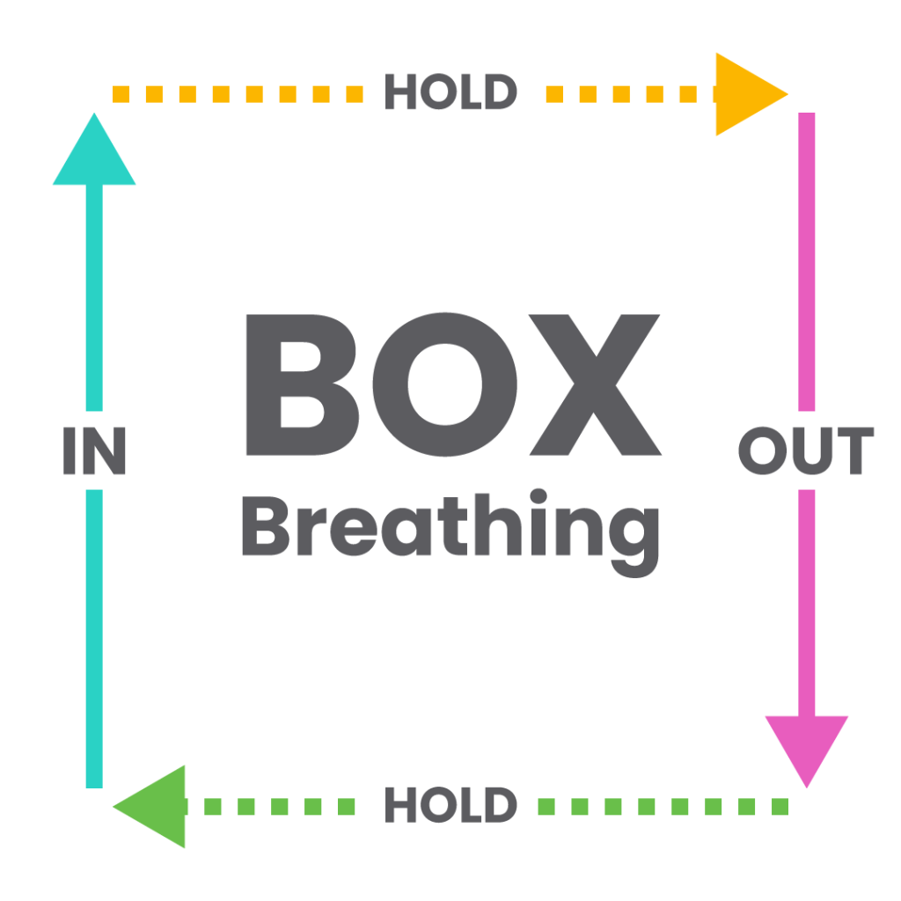
Hold for 4 seconds on each side

