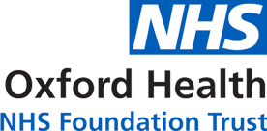

Oxford Heath NHS Foundation Trust

Privacy Notice
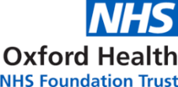 | What is Oxford Health?
 | Oxford Health is an NHS Foundation Trust.
 | We help people with their health care.
 | We are registered with the Information Commissioner’s Office (ICO) to use information about the people we work with under the Data Protection Act 2018 and our registration number is Z1411013.
 | Read more about Oxford Health here:  www.oxfordhealth.nhs.uk
 | Our services are at community bases, hospitals, clinics, and people’s home.
 | We focus on delivering care as close to somebody’s home as possible.
 | For information on all our services please visit our website. Here is the link:  https://www.oxfordhealth.nhs.uk/services/
 | Why do we collect personal information about you?
 | Personal Information is information about you or other people.
 | We need to keep information about your health, treatment, and care.
 | This is so we can give you good treatment and care.
 | Read about the ways we keep personal information:
 | On paper and in a file.
 | In an electronic patient record system.
 | Some services may wish to record part of your treatment on video or audio. We would ask you about this before we did it.
 | Some of our services use telephone recording software. This will be announced at the start of the call.
 | CCTV is used by the Trust in some internal and external areas to protect patients, employees, visitors, premises and Trust assets.
 | We may share CCTV with the Police to support them in identifying, apprehending and prosecuting offenders.
 | Oxevision is used in some inpatient wards with consent from the patient for observation and patient safety purposes.
 | We process personal information for the provision of “health care treatment to include the management of health care systems and services”.  This is a “Public Task” as set down in UK Law.
 | You can read more about the Data Protection Act 2018 by clicking this link UK Legislation Website
 | What personal information do we need to collect about you?
 | We need some information to make you a health and social care record.
 | Read more about what information we need:
 | Your name
 | Your address
 | Your telephone number
 | Your date of birth
 | Your ethnic origin
 | Contact details for your family and carers
 | Who your doctor is
 | We might also keep information about:
 | If you are married
 | Your job
 | Your religion
 | Your email address if you have one
 | Where you were born
 | If you are using the NHS as an overseas visitor
 | What you like to be called
 | We might also keep information about you which is sensitive. For example:
 | Notes about your health, treatment, and care.
 | If you have a protection order that affects your health, wellbeing, and human rights (safeguarding status)
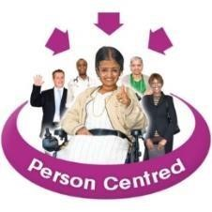 | It is important for us to have lots of information about you so that we can help you in the best way.
 | Where do we get information about you?
 | From you
 | From your GP
 | From another Hospital
 | How do we use your personal information?
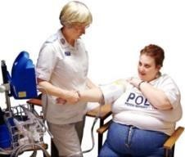 | We use it to help staff to find the best treatment or care for you.
 | We use it to make sure all the people involved in your care know what treatment you are getting.
 | We won’t tell people your name unless we really have to.
 | Read about how we might also use your information:
 | To give your information to other people who are treating you.
 | To remind you about your appointments (including SMS messaging).
 | To review our service to make it better.
 | To share your information with the people who are paying for your care. These people are called commissioners.
 | To send reports to organisations such as the Department of Health.
 | To train healthcare staff.
 | If there is a complaint.
 | If the law says we need to report something that happened.
 | To find out if you could take part in research.
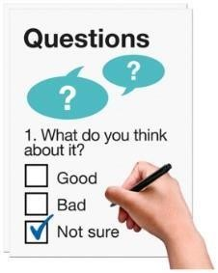 | To ask you to take a survey.
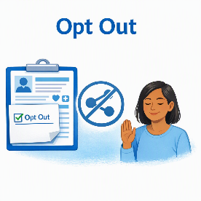 | National Data Opt Out means you have a choice about whether you want your information used for purposes like improving services or research. To opt out visit Your NHS data matters.
 | Who do we share information with and why?
 | We need to tell you how personal information will be used. We need to have a legal reason for using your information without asking you first.
 | We might need to give your information to other organisations.
 | Read about why this is.
We might share personal information with other NHS Organisations to help them give you healthcare.
This could be
- NHS England
- NHS Integrated Care Board
- Public Health England
- other NHS Trusts
- General Practitioners (GPs)
- Ambulance Services
- Primary Care Agencies
This may also include those other organisations that help the NHS to look after your health.
 | We might share personal information with organisations like Social Services or private care homes to help them give you support.
 | Sometimes the Secretary of State for Health gives special permission for information that uses your name to be used without your consent.  This may be for medical research or checking quality of care.
Sometimes, we might need to share your information because it is the law.
We will tell you when we do this.
 | Read about why this is:
 | To find out if fraud is happening.
 | If there is a court order.
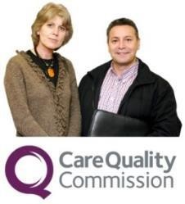 | If the Care Quality Commission need it for an inspection.
 | If the police need it to investigate a crime.
 | We use a 'Count me in' approach to research for approved medical research.  Participation is voluntary and you can speak to your clinical team if you do not want information relating to you to be used in research.
 | We contribute to the Thames Valley & Surrey Secure Data Environment (TVS SDE).
 | We collect information for the National Clinical Audit of Psychosis about the care received by people in Early Intervention in Psychosis (EIP) services.
 | We provide personal information to shared care record systems to make your care safer and more efficient.  - Thames Valley and Surrey Shared Care Record  - Bath and North East Somerset, Swindon and Wiltshire Integrated Care Record (BSW ICR)
 | How do we keep personal information that is part of a health or social care record?
 | Personal information is kept in paper and electronic format.
 | The law tells us how to keep your information. These laws include the Data Protection Act 2018, the UK GDPR, and the Common Law Duty of Confidentiality.
 | We keep information about you for as long as we need to do make your health better.  (This is in line with the NHSE Records Management Code of Practice)
 | We have to:  Maintain full and accurate records of the care we give you.
 | Give you information in a format that is accessible to you.
 | Keeping your information safe  We will make sure and keep your information safe, using computer passwords for electronic information, and locks for paper information.
 | What are your rights?
 | You can ask to see the information we have about you.  Read more in the “Your rights and access to the health care record”
 | You can ask us to change any information that is wrong.  Read more in the “Your rights and access to the health care record”
You can tell us not to share your personal information
(unless we need to because of the law)
 | You can ask us to give the records we have about you to another organisation.
 | If you have concerns regarding how we are processing information about you, please raise these with your clinical team.  If you continue to have concerns, please contact the Data Protection Officer  Mark Underwood  Email: dpo@oxfordhealth.nhs.uk  IM&T, The White Building  Littlemore Mental Health Centre  33 Sandford Road  Littlemore  Oxford, OX4 4XN.
 | You may wish to contact the Information Commissioner’s Office (ICO) if we have not been able to address your concerns.  The ICO regulates the trust under Data Protection and Freedom of Information legislation.  Information Commissioner’s Office  Wycliffe House  Water Lane  Wilmslow  Cheshire  SK9 5AF  ico.org.uk twitter.com/iconews  Helpline: 0303 123 1113  Email: accessicoinformation@ico.org.uk  Website: ico.org.uk
 | This information was put into Easy Read by My Life My Choice and has been amended by Oxford Health NHS Foundation Trust.

