

Report to the Meeting of the
BOD 108/2016
(agenda item: 9)

Oxford Health NHS Foundation Trust

Board of Directors

28th September 2016

Quarter 1 Highlight Report on the 2016/17 Quality Objectives
For Information

Executive Summary
The following report provides a summary of progress up to quarter 1 on the 2016/17 quality objectives identified in the Quality Account. The report was shared with the Quality Committee in September 2016.

The quality objectives are aligned to each of the four quality priorities;

1. Enable our workforce (progress on pages 2-11)
2. Improve patient, families and carers experiences (progress on pages 12-15)
3. Increase harm-free care (progress on pages 16-27)
4. Improve quality through service pathway remodelling and innovation (progress son pages 28-35)

Recommendation
For the report to be noted.

Author and Title: Jane Kershaw, Acting Head of Quality and Safety
Lead Executive Director: Ros Alstead, Director of Nursing and Clinical Standards

A risk assessment has been undertaken around the legal issues that this paper presents and there are no issues that need to be referred to the Trust Solicitors.

Q1 Highlight Report on the 2016/17 Quality Objectives
(‘looking back’ section in the Quality Account)

The quality objectives are aligned to each of the four quality priorities;
1. Enable our workforce (progress on pages 2-11)
2. Improve patient, families and carers experiences (progress on pages 12-15)
3. Increase harm-free care (progress on pages 16-27)
4. Improve quality through service pathway remodelling and innovation (progress son pages 28-35)

Number | Quality Priority | Link to Trusts business priorities for 2016/17 | Link to CQC quality domains
1 | Enable our workforce to deliver services which are caring, safe and excellent | - To support teams to improve the safety and quality of care they provide  - To support leaders to maintain a positive culture for teams. | Well led

Number | Objectives | Trust wide/ Directorate | Progress Q1 - April-June 2016  (based on suggested measure)
1.1 | Implement the relevant actions for 2016/17 from the nursing strategy.  The six work streams are;  - what patients want from nurses,  - valuing nurses  - ensuring high professional standards  - developing career pathways  - contributing fully to multi-disciplinary team practice  - developing and supporting professional and clinical leadership. | Trust wide | Narrative progress report on achievement of actions in strategy for 2016/17  Progress against the strategy has been slightly delayed and will be reported in Q2. A lead for each work stream has been identified and work has started. The trust has also carried out a gap analysis against the international Magnet accreditation scheme which is focused on the quality of nursing to support the trusts own nursing strategy.  The trust is supporting 1800 nurses to revalidate over the next 3 years. At the end of Q1 99% of nurses were up to date with revalidation.  The Heads of Nursing are key members of the newly reformed trust wide recruitment action group which has prioritised the following actions:  - Career development  - Consistent offer on attraction/retention – to include financial incentives  - Marketing and key attraction messages  - Accommodation  - International recruitment  - Careers/resource centre  To raise the profile and celebrate 125 years of nursing education a garden party was held by the trust in July 2016. This was used as an opportunity to launch the nursing strategy.  Vacancies  Target 9% or less  June 2016 11.02% (10.10% May 2016)  Vacancies have increased in all directorates except Corporate services. However we are actively recruiting to vacant posts.  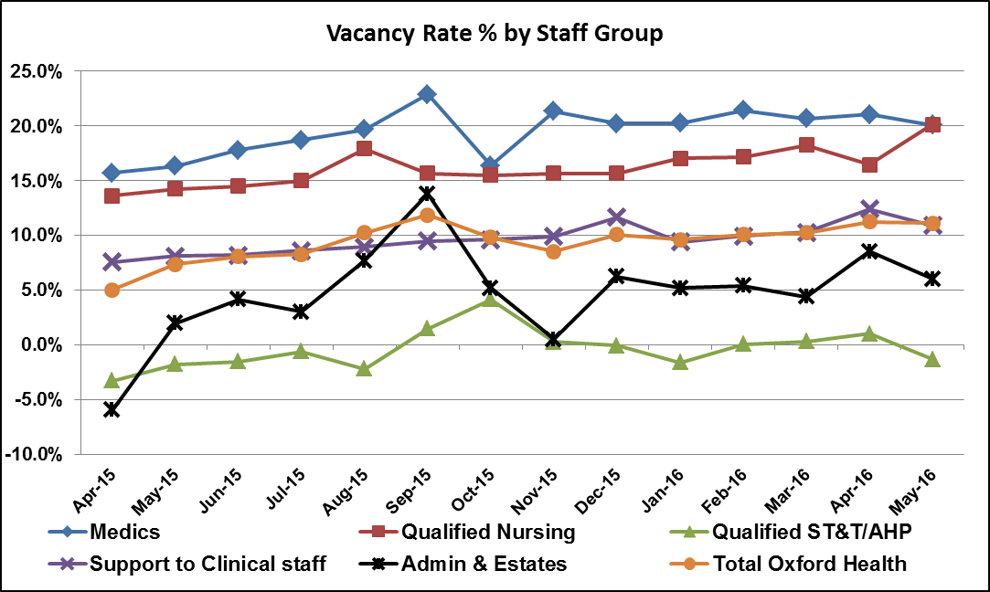  Turnover  Target 12% or less  June 2016 14.14% (14.27% May 2016)  Turnover has increased/ remained for adult and older people services and declined for children and young people services. The HR Department is introducing a process that will enable it to focus on exit reasons for an initial period of 2 months (although this may be extended). The information gathered will be reviewed and should provide “real time” information about the reasons people change role. It will have the additional advantage of enabling the Trust to report internal turnover (churn) for the first time.  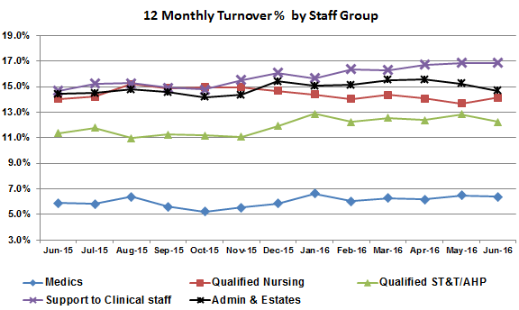  Inpatient staffing  In Q1 the following wards are highlighted as struggling to meet staffing levels, related mostly to nurses;  - Ruby (overall 77.3% of shifts fully staffed)-high number of vacancies (7.8 WTE), high sickness (5.3%) and particularly high agency use (22.8%) to maintain safe nurse staffing levels. The ward has struggled across all four weeks, particularly with registered staff on day and night shifts. Additional unregistered staff have been used to staff shifts below for registered staff.  - Vaughan Thomas (overall 72.4% of shifts fully staffed)-high number of vacancies resulting in high agency use (13.7%). The ward has struggled across all four weeks, particularly registered staff on day shifts.  - Watling (overall 84.7% of shifts fully staffed) - high number of vacancies (10.7 WTE) and high sickness. The ward has struggled across all four weeks. There has been a high use of bank staff and changes in skill mix from registered to unregistered staff to maintain safe staffing levels.  The other wards to note which are having staffing challenges are;  - Ward 1 in Abingdon community hospital  - Ashurst PICU  - Highfield  - Kestrel  - Kingfisher  In particular maintaining staffing across Kestrel and Kingfisher wards is very difficult, combined with a challenging patient group, the ward is reliant on long term agency staff. A focused piece of work is being led by the Director of Nursing to support the directorate senior management team and staff on the ward, and to review the care being delivered.  Staff feedback  2015 staff survey results had an improved response rate of 48% of all staff. Overall engagement score was 3.81 the same as the average, with the lowest trust at 3.64 and the best trust at 4.02. The questions that form the engagement score are considered a good indicator for trusts and our results broken down by directorate are shown below. The Executive Team held workshops with team/ ward managers and senior managers in June and July 2016 to discuss and identify areas for improvement from the staff survey results.
1.2 | Implement the relevant actions for 2016/17 from the workforce strategy.  key areas identified are to;  - Diversify ways to attract the best staff including considering international recruitment  - Expand the types of roles and ways to enter a career in the NHS e.g. graduates, apprenticeships, work experience, school visits  - Optimise recruitment processes  - Enable and support staff to work in different geographical locations e.g. with housing and introducing financial incentives  - Develop our own staff to fill some of the gaps in skills  - Retain our staff looking at career paths, variety within jobs, flexibility and support  - Develop the current performance development review process and system to fully embed the trusts values and behaviours. | Trust wide | Narrative progress report on achievement of actions in strategy for 2016/17  Expanding the types of roles  Apprenticeships are being increased with 17 apprentices starting in April 2016 and assessment days being held in July for a second cohort to start in Sept 2016.  In addition peer support workers (people with lived experience) are being employed to work alongside professionals, and through the Oxfordshire mental health partnership information, advice and employment workers are working as part of adult mental health teams.  Recruitment action group  See details about the trust wide recruitment action group above.  Values Based Behavioural Framework  14 focus groups have taken place throughout June and July 2016 with a total of 140 staff participating in the groups. The output from these sessions is being used to develop 5 more detailed frameworks regarding acceptable and unacceptable behaviours. Feedback sessions were held in August 2016 and the final frameworks will hopefully be approved in September 2016. The behaviours will be used in the recruitment process and the PDR system.  Staff health and well being  Work continues led by the trust wide health and well-being group. The group has set the following priorities for 2016/17 which are supported by a health and well-being action plan.  - To support our workforce to be active and healthy, and are able to perform to the best of their physical abilities  - To support an inclusive workplace where staff feel safe to raise concerns and are provided with the tools to look after their own emotional and psychological wellbeing  - To support an organisational culture where staff feel a strong sense of belonging and view Oxford Health NHS FT as an enjoyable place to work  Recent work by the group includes-  - #MakeItHappen - an initiative to empower staff to work with the Health & Wellbeing Action Group to bring ideas and initiatives to life. A simple application process has been developed including support that might be required (mentorship, practical assistance and funding).  - Bike User Group Breakfasts - As part of National Bike Week we supported four bike breakfasts at Blackbird Leys, Abingdon, Witney and Littlemore sites to encourage staff to cycle to work.  - Health & Wellbeing Champions - In a recent networking event, the Wellbeing Champions agreed a purpose statement. Champions are currently being contacted to find out more about what they got involved, to raise awareness of the wellbeing #champions as ambassadors for health and wellbeing across the Trust, motivate staff to get involved, demonstrate that the Trust is taking staff wellbeing to heart.  Three staff equality networks have been set up to meet bi-monthly with the first meetings held in April 2016, around race equity (15 members so far), disability equality (12 members so far) and LGBT inclusion (25 members so far). The purpose of these networks is to create a community of support and the infrastructure for engaging with staff in a meaningful way on related equality initiatives. The theme for the next senior leaders workshops in September 2016 is equality and diversity.  PDR Review Update  A project to review the appraisal process was formed and embraces both the introduction of the Trust’s values/behaviours and the incorporation of changes arising from Agenda for Change. Key elements of this include:  - The design of an on-line PDR system.  - The ability to utilise online PDR and Personal Development Plans to inform future talent management and training needs.  - A review process for incremental pay linked to performance.  The new PDR tool has been created in-house which was due to be launched in Q1 but has been delayed and will launch later in 2016 which will give the trust the ability for Talent Management and develop aspiring leaders of the future.  Workforce indicators  See above vacancy, turnover and staffing level figures.  Bank and agency use  Target 5% of less.  Bank & Agency spend has increased significantly over the last two months rising from 5.35% in April 2016 to 6.17% in May 2016 and 7.16% in June 2016. These figures now relate purely to Agency spend following the absorption of NHS Professional staff into the Trust. The increase has applied to all Directorates. The greatest spend in June has occurred in Oxfordshire PCAMHS, Kestrel Ward, Oxon CAMHS (Medical), Podiatry Services and Highfield (Oxford).  The spike in March 2016 relates to the Adult directorate, the main reasons for the higher use in Q1 are;  - To support vacancies on wards particularly Thames House (Kingfisher and Kestrel)  - To support Community teams covering vacancies and long term sickness.  - EIS, Pirls, Street Triage require agency support to cover vacancies, sickness, and recruitment to support increased establishments.  - 8.5 WTE agency workers have been recruited to deliver Psychological Services in the AMHT’s prior to the restructure of Step 4 services starting in Aug/Sept 2016, to reduce waiting times.  - 6 WTE CPNs have been added to the establishment of Oxford City AMHT and will be filled by agency until they can be substantively recruited. Recruitment has started.  - Medical vacancies continue to be a challenge specifically in CAMHS and urgent care and are being covered by agency/locums, and within price caps, where achievable. This is having an impact on service capacity and is included in relevant risk registers to mitigate and monitor the impact.  The Adult Directorate have begun to review the recruitment campaigns to understand how we can attract more staff to the Trust. One of the key pieces of work which have been underway has been the creation of a video featuring a number of staff across the directorate talking about why they chose to work for OHFT – and more importantly what keeps them here. The video was filmed during July 2016 and is in editing at the moment ahead of its launch in September 2016. The digital campaign will be hosted across Facebook, Twitter and LinkedIn for 2 months.
1.3 | Re-establish a programme of peer reviews to encourage learning and sharing between teams and as an approach to listening to staff about their experiences | Trust wide | All adult mental health wards and community teams (n=14) received a peer review visit between April-May 2016 all including at least 1 carer or service user. The older people’s directorate have completed 5 peer reviews in Q1 and a further 3 so far in Q2. Staff within the children and young people directorate have been supporting the reviews in the other directorates so have not carried out any peer reviews in the children’s services in Q1. In a number of the review people with experience have been part of the review team.  The themes from the reviews will be reported from Q2.
1.4 | Continue to embed and develop the electronic health record to support and enable staff | Trust wide | System developments  In July 2016 a second attempt was successful in updating the version of Carenotes used by the community health services. This now means both versions of Carenotes in use in mental health and community health services are the latest release of the product (the agreed baseline version).  A number of technical issues with Carenotes are still being worked through with the provider of the software to improve functionality.  Revisions to clinical tools  Recent updates include a revised and implemented new mental health care plan template and risk assessment template. Plus a new dashboard view for each member of staff to show the patients assigned to them and whether key documentation is present and date last updated. The EHR transformation team continue to support teams and to develop user guides. Further work is needed to continue work on personalising care plans and ensuring copies of care plans/ risk assessments are offered to patients/ clients. Currently there are a review of the number of physical healthcare forms being used across the trust and where physical health information is being recorded.  Data quality improvements  Data quality issues around recording/ amending inpatient admission, transfer and discharge dates have been resolved and this is now managed by the health records team.
1.5 | Implement development pathways for staff, with consideration to identifying talent and succession planning | Trust wide | Following successful pilots for bands 1-4, new development pathways have been created for our apprentices through to band 8. These will replace the existing pick & mix selection of courses to provide a clear development pathway.  These pathways have been designed with the trusts values underpinning all the sessions. Healthy Conversations module is the first session for all bands to ensure that all staff are confident and competent to be able to communicate effectively to other staff, patients and carers. This module has been designed to ensure that all staff have a voice and a way to have a meaningful conversation. Effective team based working (Aston Team based working) is another essential element underpinning the development pathways alongside developing quality improvement skills.  These pathways will ensure that we can internally develop our staff and talent manage to develop them further with the National Leadership Academy Programmes. The pathways have been further enriched using MBTI (Myers Briggs Type Indicator) step 1 & 2 to support. The pathways are:  - Apprentices ‘Development Pathway  - Bands 1-4 Administration Development Pathway  - Band 5 Team Leader Development Pathway  - Band 6 Management Skills Development Pathway  - Band 7 Advanced Management Skills Development Pathway  - Band 8 Strategic Leadership Skills Development Pathway  The roll out of the development pathways has been delayed, although there has been a pilot of the band 5 pathway from July 2016.

Number | Quality Priority | Link to Trusts business priorities for 2016/17 | Link to CQC quality domains
2 | Improve patients, families and carers experiences through involving people in their own care and how services develop | To make care a joint endeavour with patients, families and carers | Caring and Responsive

Number | Objectives | Trust wide/ Directorate | Progress Q1 - April-June 2016  (based on suggested measure)
2.1 | Implement the relevant actions in 2016/17 from the patient involvement and experience strategy.  The aims of the new three year strategy are to;  i) Develop a culture which encourages, supports and develops effective partnerships between people who use Trust services and their carers/ families and professionals,  ii) improve the experiences of people who use services and their carers/ families, and  iii) improve the opportunities of how people are involved to identify issues and actions to improve services | Trust wide | New Strategy  The strategy was co-developed with patients, families/ carers and staff and finalised in April 2016 by the board of directors. The taking action on patient feedback group has had two workshops in May and July 16 to develop and prioritise a work plan for the next 3 years. This work plan has been agreed however further work is needed to identify the additional resources needed to deliver the strategy. A number of the actions in the work plan have started already, one of the key areas in year 1 is the re-tender of how we collect and report on feedback. The tender application will be going out in early Sept 2016.  Feedback  The CQCs recent re-inspection of adult mental health services in June 2016 recognised the significant improvement made and has re-rated the trust as overall Good. The CQC rated caring as good for the following reasons;  • Across all core services we rated the trust as good or outstanding for caring and found that people were treated with dignity, respect and kindness.”  • Patients and carers we spoke with commented that the staff were extremely caring and reassuring even during times of restraint.  • In mental health inpatient services carers we spoke with said they felt highly involved and regularly updated by all of the MDT teams on the wards. Carers and family members, with patient consent, were invited to MDT meetings and ward rounds. Some wards offered family support group sessions and most held monthly carers groups. Carer assessments were offered to carers by the patients care coordinator.  • The majority of patients we spoke with were aware of their care plan and said that they were involved with devising one and felt they received sufficient information to make informed decisions about their care.  Overwhelming the feedback we have received from patients, families and carers is very positive with patients reporting feeling cared for by staff and that as a result they highly value the service provided. In Q1 94.6% of patients (n=2876) told us they were extremely likely or likely to recommend our services to a friend or family member if they needed them. However some people do not receive the positive experience we expect every person to have and therefore we have more work to do. The themes highlighted from complaints mirror the key areas for improvement identified from the feedback we receive, and are focused on communication and sharing information with patients and their families/carers to enable joint decision making and full involvement in care.  The 2015 staff survey asks about how effectively staff use patient feedback, we have improved from 2014 to 2015 and are slightly above the national average, detailed by the graph below.
2.2 | Maintain the ‘Triangle of Care’ external accreditation, actions for 2016/17 will include:  i) ensuring all teams/ wards complete a self-assessment  ii) carer/ family awareness training is rolled out  iii) information provided to carers/ families is reviewed including the information available on the Trust’s website. | Trust wide | 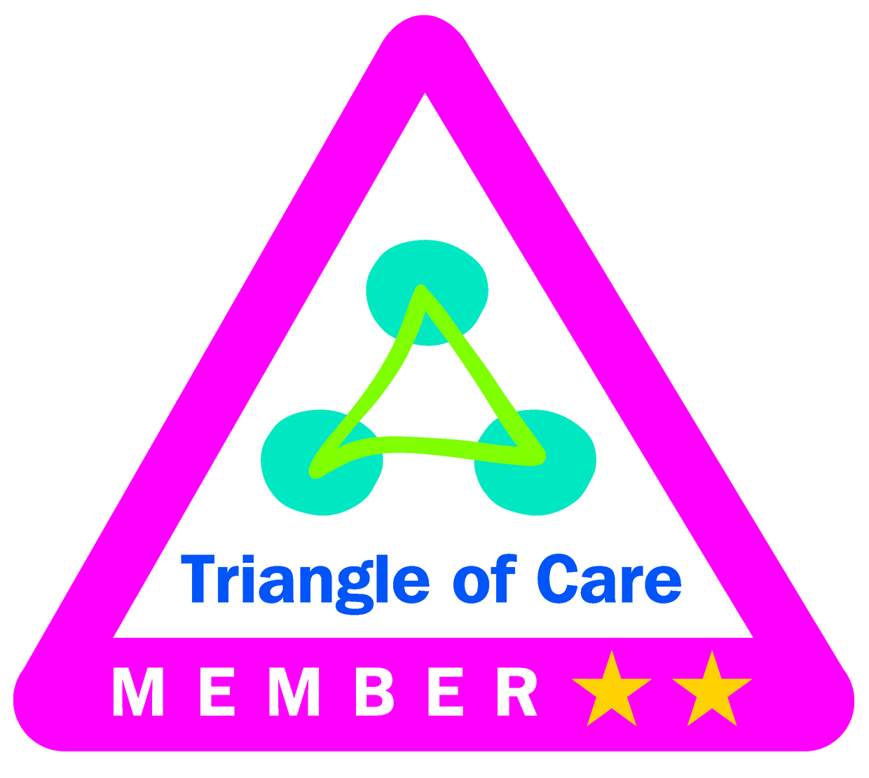The trust has been a member of the national triangle of care scheme since May 2014, recognising the importance of carers, families, patients and staff. The teams have been working hard over the last year to implement and demonstrate meeting the national carer standards within the triangle of care. Carers and voluntary organisations have been involved in the process from the start and their feedback has been important to identifying and monitoring actions. So far over 40 self-assessments at team/ ward level have been completed, these have mostly been across mental health services in children, adult and older people services including community and inpatient teams. Following the self-assessments local actions have been taken for example; identifying carer/ think family leads in teams, establishing carer lead forums, reviewing information given out by teams, recognising the changing role of parents/ carers in the transition planning from children and adult services, setting up new carer groups, and carrying out regular telephone surveys with carers.  In December 2015 the Carers Trust accredited the trust with two gold stars, the third (and last star) will be achieved when all teams/ wards (this includes the community physical health teams) have completed the self-assessment and identified/ addressed any gaps. In 2016 the teams which completed an initial self-assessment have reviewed the assessment and updated the actions being focused on. In the older people directorate this review has included audited a couple of cases in each team by reviewing care notes, meeting with care coordinators and speaking to carers. The trust is due to present the updated self-assessments for the mental health services and decide whether to try for three stars in the Carers Trust regional meeting in November 2016. The directorate carer leads have continued to maintain the momentum in relation to the triangle of care.  The carer awareness training developed by Rethink and carers has been piloted and is due to be rolled out shortly. Each directorate has reviewed the carer information given out at team and ward level. The review of the internet information will be led by the trusts web strategy group and has not started yet.  The trust has just started a piece of work with Oxford University Hospitals NHS FT, Oxfordshire county council, Oxfordshire clinical commissioning group and a number of voluntary carer organisations to develop a carers charter implemented across the organisations in Oxfordshire.
2.3 | Young people and their families involved in designing and delivering safer care work | Children and Young People | Update to be provided in Q2.
2.4 | Introduce the Buckinghamshire Recovery College ensuring we have co-design and co-production as standard practice | Adult | The trust, Buckinghamshire MIND and Buckinghamshire Adult Learning are working together to open the Buckinghamshire recovery college in Sept/ Oct 2016. The structures and planning behind setting up the college are well progressed with key leadership posts in place, and good patient and carer involvement in the steering groups to set up the co-designed and co-delivered courses and to look at the promotion and advertising for the college.
2.5 | Promoting effective use of ‘Knowing Me’ passport in older people inpatient and community mental health teams | Older People | The ‘knowing me’ passport is completed for patients with dementia with the family where possible and kept in their rooms, when they are discharged this remains with them. Family have found these pleasing and a therapeutic tool to complete and patients use these to draw pictures etc. in. This is useful as a tool for further admission to nursing home although no official feedback received. Further work is underway to review the impact of using this approach.

Number | Quality Priority | Link to Trusts business priorities for 2016/17 | Link to CQC quality domains
3 | Increase harm-free care | To support teams to improve the safety and quality of care they provide | Safety

Number | Objectives | Trust wide/ Directorate | Progress Q1 - April-June 2016  (based on suggested measure)
3.1 | Reduce the need for restraint and monitor the use of seclusion and long term segregation by implementing the actions from the PEACE project for 2016/17.  The actions are set against the following areas:  i) workforce development, ii) leadership, iii) service user/ patient involvement, iv) use of data to inform practice, v) rigorous debriefing, vi) development of resources, vii) identify and minimise other restrictive practice | Trust wide | The work plan for the PEACE project is embedded within the nursing strategy.  A weekly report of all episodes of restraint, seclusion and long term segregation is discussed at the weekly clinical review meeting. The meeting is advised of the number of restraints by ward, and the number of prone (face down) restraints. The meeting has noted a reduction in the number of prone restraints across inpatient areas, and is now looking at the data around the length of time that patients are restrained in the prone position. Any concerns are highlighted to the relevant head of nursing who will carry out an additional review if required to ensure the restraint or seclusion was appropriate. The high use of seclusion in quarter 1 and quarter 2 relates to a small number of patients who were presenting very complex needs which required regular seclusion as part of their care.  In Q1 there were 521 restraints, of which 168 involved the same 6 patients with 1 patient on the women’s forensic low secure ward accounting for almost 10% of all restraints across the Trust. The majority of the restraints were as a result of violence and aggression (n=247) or self-harm (n=182). There were 107 incidents of a patient being secluded, in majority relating to 7 patients across four wards. 2 of the patients accounted for 22% of the total number of episodes of seclusion. Q2 update will include information on the number of long term segregation episodes.  From 1st July 2016 the incident form for reporting restraints, seclusions and segregation was revised to improve the quality of information captured. Q2 will be able to report on this additional information available.  Training  In 2015/16 the trust carried out an extensive review of all available national training programmes and we developed a tailored programme called PEACE (positive engagement and calm environments) to support staff and at the same time reduce the need to use restrictive interventions. The training also includes principles of positive support planning and trauma informed care, and the establishment of a PEACE champion in every inpatient ward. From 1st April 2016 the previous PMVA training was revised and rebranded as PEACE training. The training includes four day training for new starters and a 1 day refresher for existing staff. In addition there will be a four day PEACE foundation training delivered and tailored to teams to support a change in culture. The Highfield ward team successfully piloted the new four day PEACE foundation team training. There is a provisional plan to roll out the PEACE foundation training to every team over the next two years, although the roll out has been delayed. There are also discussions being held with the Community Hospitals about their needs for training on physical restraint has also begun.  Following recent feedback from staff on some wards which have received the new starter and refresher PEACE training (although not the foundation team training), there are concerns the number of violence and aggression incidents have increased and that staff by reducing the use of restrictive interventions are feeling more vulnerable/ unsafe. In response to this feedback the head of nursing which leads on restrictive practice is working with the specific wards and the PEACE training team.
3.2 | Prevention of suicide | Trust wide | The number of suspected suicides continues to show a downward trend each quarter from 2014/15 Q4, see graph below.  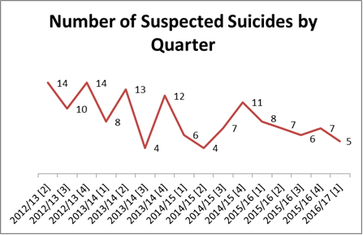  More detail about the work bring carried out will be provided in the Q2 update.
3.3 | Implement learning from incidents (including serious incidents) | Trust wide | Analysis of incidents  The number of incidents reported during Q1 was 3414; this is an increase on Q4 and reflects an increase in incident reporting seen in all except 2 of the last 11 quarters.  Local and trust wide innovations seek to challenge some of the barriers to reporting and learning from incidents. These developments include shortening the incident report form for up to 20 incident types, optimising the use of the incident report form in iPad and improving the information available around incidents. The Quality and Risk Team will be engaged in the development pathways for bands 5-8 across the Trust with incident reporting/ learning and duty of candour requirements forming part of a modular approach to improving the skills and knowledge of staff.  The numbers of reported green and yellow incidents (low/minor injury or property damage) continues to represent the highest proportion of total reported incidents in Q1. Of the 3414 incidents, 2127 reported no harm, 1015 reported minor harm or property damage, 196 moderate harm or property damage and 81 were reported as causing major harm or property damage or were a death.  The top three types of incidents are violence and aggression (most patient on staff with no injury, skin integrity (relating to older people services, of which 26% grade 3 or 4) and self-harm (relating to cutting and ligature with 1 of 461 incidents resulting in major harm).  A higher number of Serious Incident (SI) investigations are being undertaken, due to the change in the national SI framework, this rose to 40 in Q1, resulting in an adverse impact upon meeting the national 60 day target for submission of finalised reports to the clinical commissioning groups. However the quality of investigations has been commended by the commissioners. The main issue relates to capacity; from identifying the ‘right’ authors to getting appropriate representatives at our internal SI panel review. Additional resource for investigations was introduced from February 2016 and May 2016 to support some of the capacity difficulties. The trust has developed an improvement plan with the clinical commissioning groups to focus on continuing to improve the timeliness of investigations and quality of action plans going forward.  Learning  We have a positive culture in reporting and wanting to learn from incidents and deaths. Informed by a continuing increase in the number of incidents reported and the last annual ‘learning from mistakes’ league table produced by Monitor (now called NHS Improvement) based on the staff survey and information submitted to the national reporting and learning system (NRLS), which the trust was rated as good.  All reported orange incidents, serious incidents and unexpected deaths are reviewed weekly in a meeting by senior clinicians. Quick time learning is identified each week and immediate actions are identified and taken as required.  A range of mechanisms are used to share and embed learning e.g. key learning posters, written reports, attending clinical governance meetings, newsletters, learning events, separate section on the staff intranet, risk notes, feeding into staff training etc... The internal panels held to review the investigations and actions from all serious incidents also helps to share learning.  Centrally we monitor the completion of actions identified following serious incident investigations. There are currently some outstanding actions although these are reducing each month and continue to be actively followed up. Testing of completed actions in services is due to start shortly to ensure improvements are sustained.  We need to continue to improve how we learn and embed changes, which will be linked to objective 4.1 below.
3.4 | Improve analysis, review and learning from unexpected deaths by implementing the work streams below;  - Establish a new trust-wide mortality review group  - Review and communicate agreed definitions, expectations for reporting and investigation  - Agree system-wide approach for review and learning from deaths with relevant external partners  - Improve accuracy of data on deaths  - Improve the use of data on deaths  - Bring consistency to thematic reviews  - Review timeliness and completion of duty of candour | Trust wide | Analysis of deaths  In 2015/16 we carried out a root cause analysis into 26 deaths (all relating to mental health services) managed through the SI process.  In Q1 56 deaths were reported compared to 50 in Q4. 9 of the 56 deaths in Q1 are being investigated and managed through the SI process.  Since June 2015 the trust has reviewed all unexpected deaths reported on the incident system in the weekly clinical review meeting. The meeting reviews information on the death and will commission a further root cause analysis investigation as appropriate where the death is classified as a serious incident. The purpose of the investigation is to identify any contributory factors and to look at how we can learn and improve. All unexpected child deaths are reviewed through the child death overview process (CDOP) led by the safeguarding boards which involves a multi-agency review of all deaths of children (up to the age of 18).  There has been an increase in the culture of reporting deaths in Q1 2016/17 compared with last year, this could possibly be due to an increased awareness and profile around reviewing and reporting deaths. The majority of deaths reported related to unexpected deaths in the community whilst being currently seen or seen in the last six months by mental health services.  It is recognised that only about half of all deaths for current and recently seen patients (within the last six months) are reported on the incident system, shown through comparison with extracts of the patient electronic systems checked against the national deceased database. Although we would not expect all deaths to be reported on the incident system e.g. expected natural deaths, the number of deaths reported and being reviewed will increase in the next year.  Progress with work  The mortality review group replaced the previous project team and first met in June 2016. So far the group has met twice chaired by the Medical Director and reports to the Safety quality sub-committee. The terms of reference for the group have been approved.  The Trust has started some work with the Mazars Group in July 2016 to improve how we identify, report and review deaths from all of the trusts services. The work with the Mazars Group includes; reviewing our own self-assessment against national recommendations, observing the trust wide Mortality Review Group in August 2016, facilitating a workshop to review our data streams and how data is analysed and used in August 2016, reviewing a sample of IIRs and SI investigations into deaths and facilitating a workshop in Sept 2016 with senior clinicians to look at how we categorise deaths and develop a local reflection tool for teams.  There is clear commitment to involving families in a timely way in investigations and we have some highly skilled staff that do it very well. We are working on improving confidence across a wider range of staff, through training (making families count training was delivered in Q1), so they feel confident in their ability to make contact and engage in meaningful and supportive conversations. Family engagement is promoted for all investigations managed through the serious incident process, which means an investigator has to justify why they have not involved the family.
3.5 | Improving physical healthcare across the mental health pathway | Adult | Inpatient  The adult acute ward performance on the bi-monthly essential standards audit continues to show positive results around physical health monitoring, evidence below.  In our inpatient services, the interim discharge summaries are sent to GPs within 24 hours of patients being discharged from the units. This ensures that the patients GPs is up to date with their care upon discharge and informed of any medication / on-going treatment needs. The inpatient wards have consistently met the target of 95% in Q1.  Community teams  The adult mental health teams and forensic community team performance on the CPA quarterly audit show positive results around identifying and monitoring patients physical health needs. A summary of the results is below;  - Where physical health needs have been identified for patients, the standard for the care plan addressing the physical health needs has consistently been rated as good.  - For service users who are on psychotropic medication, the standard relating to the care plan detailing the medication prescribed was also rated as good in both Q4 15/16 and Q1 16/17.  - Informing the GP about the need for ongoing monitoring of psychotropic medication issues has improved from requiring improvement (70%) in Q3 15/16 to a rating of excellent (95%) in Q1 of 16/17.  - Ensuring that the care plan details the side effect monitoring requirements relating to psychotropic medication remains an area rated as requiring improvement; however this has improved from 61% in Q3 15/16 to 70% in Q1 16/17.  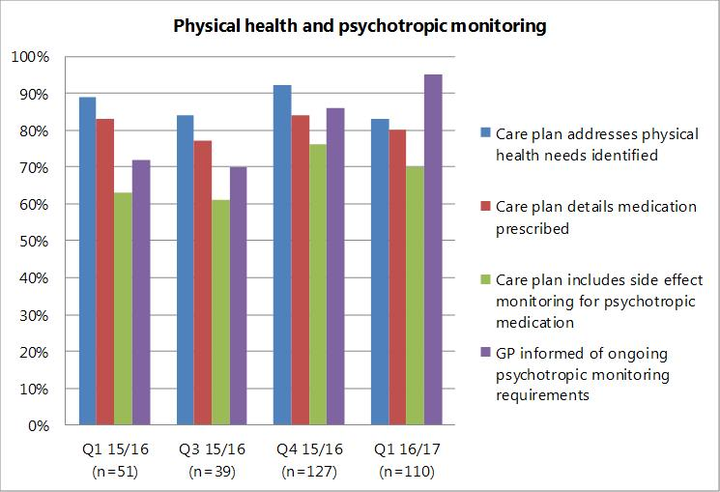  As part of the work to support long term conditions, the IAPT team are also planning to go into partnership with Parkwood Healthcare, Buckinghamshire Healthcare NHS Trust and Weight Watchers as part of the Live Well Stay Well initiative, which supports individuals who need help to lose weight and become more active, stop smoking or receive support for the emotional challenges which are experienced when managing a long-term condition. The team have been working closely to understand how a single point of access will enable people to self-refer to the hub as well as allowing professionals to sign-post patients to the service if they could benefit. The service will commence later in 2016 though has been operating in part during Q1. Alongside this, the IAPT service is also working with CV Health to support the Weigh Forward Bucks, this is a specialist weight loss service in Buckinghamshire with a dietician, CBT practitioner, psychology assistant and exercise specialist. Groups are offered in the community for patients as well as one-to-one sessions for those requiring more intensive support.  The directorate is involved in the work mentioned above to review and reduce the number of forms used to record and monitor physical health on Carenotes.
3.6 | Reduce the number of grade 3 and 4 pressure ulcers deemed a serious incident (where we have found contributory factors in care delivered), through delivering the actions identified for 2016/17 in the pressure damage improvement plan | Older People | Project work  The trusts pressure damage reduction project aims to reduce harm to patients whilst in receipt of care through the prevention of acquired pressure tissue damage. This reduction in pressure damage will be achieved by:  - Embedding effective systematic quick time responses to pressure damage  - The use of an evidence based quality improvement methodology that is data driven and based on rapid tests of change.  A Steering Group has been established and an improvement plan has been agreed with the Oxfordshire Clinical Commissioning Group who are members of this group. The group is chaired by the service director for older peoples services.  The work is being focused on six teams, 3 teams are progressing well and 3 teams are still at an early stage. Key achievements include; remodelling the incident reporting system to better support effective quick time learning and responsiveness to category two pressure damage. However currently the amount of pressure damage does not seem to be reducing, despite focused work in quarter 1. Most of the damage is category 2.  There are early signs that a React to Red programme to support early recognition and treatment of pressure damage in reablement services is having a positive impact. A standard operating procedure has been developed to improve quick time learning in Community Teams and further work is required to embed this in services from July 2016.  Across the older people services at the end of Q1, 81% of staff had completed the pressure damage prevention and management training.  Analysis of data  In Q1 568 pressure damage incidents were reported, all but 1 of these was reported in the Older People directorate. The majority of pressure damage is grade 2, as seen in the graph below.  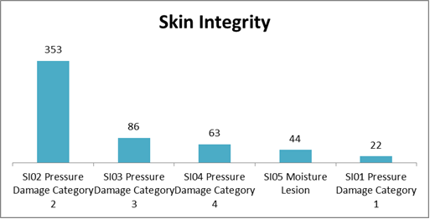  The table below shows the number of grade 3 and 4 pressure ulcers (n=149) split by inherited and those developed in our services. In Q1 there were 7 grade 3 and 4 pressure damage incidents reported and being investigated as an SI, this compares to 6 in Q4 and 5 in Q3. All figures are refreshed at the time of this report as incidents initially thought to be an SI can be downgraded by the Clinical Commissioning Group following a review of the investigation.
  Total number of grade 3 and 4 pressure damage | 149
  Number of grade 3/4 pressure damage that were inherited | 68 | 46%
  Number of grade 3/4 pressure damage that developed whilst under the care of Oxford Health | 81 | 54%
  Number of grade 3/4 pressure damage investigated through the SI process as high risk incidents by Oxford Health | 7 | 4.7%
3.7 | Improving the physical health assessment and monitoring in community hospitals to detect and manage deteriorating patients | Older People | The revised NEWS tool has been piloted and from July 2016 has been rolled out across all wards. The tool is to support staff on identifying, tracking and managing a patient when their physical health deteriorates. The training delivered has been reviewed and additional training with different content for registered and unregistered staff is to be procured and delivered based on developing competency. This is likely to be ALERT training for registered staff and BEACH training for unregistered staff.  The themes from SI investigated completed in Q1 are; staff confidence and competence (training), incomplete use of previous NEWs tool to lead to proactive management, and engagement of medical staff (employed through a contract).  There have been no new SIs around a deteriorating patient reported in Q1.
3.8 | Review the diabetes care provided across community hospitals and implement the actions identified | Older People | A new post has been developed for a diabetes specialist nurse, who is due to start from Sept/ Oct 2016. In the meantime we have purchased e-learning for staff on diabetes care and recorded an education film on use on insulin pens.  Over the last year the care pathway has been reviewed by commissioners, we are still waiting for the outcome.
3.9 | Reduce the number of patients harmed by a fall while an inpatient on an older people physical health or mental health ward | Older People | In Q1 there are currently 4 falls reported across the older people wards that have resulted in harm, all being investigated through the SI process. In Q4 there was 1 reported fall with harm. All figures are refreshed at the time of this report as incidents initially thought to be an SI can be downgraded by the CCG following a review of the investigation.  A quarterly falls audit is carried out and the results for Q1 are improved from Q4, seen in graph below. The audit in Q1 showed 72% of records had a falls risk assessment completed within 72 hours of admission and 89% of risk assessments had been reviewed within 1 week of a patient having been on the ward.

Number | Quality Priority | Link to Trusts business priorities for 2016/17 | Link to CQC quality domains
4 | Improve quality through service pathway remodelling and innovation | - To improve the quality of care by transforming services  - To lead research and adopt evidence that improves the quality of care  - To embed and enhance the electronic health record. | Effective and Responsive

Number | Objectives | Trust wide/ Directorate | Progress Q1 - April-June 2016  (based on suggested measure)
4.1 | Learn from the many improvements already made and improve on a larger scale. This will be achieved by adopting a single model for improvement, learning from partners outside the organisation, and encouraging and supporting staff to identify areas for improvement. | Trust wide | The concept of a new quality institute is being developed which would be a shared developed with the Academic Health Science Network. Research would inform and work alongside the improvement activity. The agreed approach for improvement will be that used by the Institute for Healthcare Improvement based on a plan, do, study and act cycle. Measurement will be at the heart of the approach from the beginning to after a change is introduced.  Further detail will be available in Q2.
4.2 | Continue to roll out and evaluate Cognitive Behavioural Therapy (CBT) service in Oxfordshire dentist service to reduce the need for sedation | Children and Young People | Update to be provided in Q2.
4.3 | Buckinghamshire Speech and Language Therapy - increase the support for self-management and use of assisted technology to improve care and patients outcomes, measured through Therapy Outcome Measures (TOMs) | Children and Young People | Update to be provided in Q2.
4.4 | Implement new Oxfordshire Phoenix team for children in special circumstances (bringing together Looked After Children, Youth Offending Service, Kingfisher and Residential Edge of Care teams) | Children and Young People | Update to be provided in Q2.
4.5 | Implement new Oxfordshire service model through Horizon team for young people and their families who are experiencing distress as a result of sexual harm | Children and Young People | Update to be provided in Q2.
4.6 | Improve quality of service for children and young people with a learning disability and mental health condition across all five counties, by increasing staff skills through providing evidence based training on Positive Behaviour Support (PBS) | Children and Young People | The community team staff attended a 5 day PBS training session at end of June/ beginning of July 2016, based around;  - Understanding persons behaviour and interactions with environment  - Teaching person (patient) new ways to communicate needs  The team have been using some of these approaches previously but have not had the formal training before.
4.7 | Child and Adolescent Mental Health Services (CAMHS) across all five counties; implement the newly remodelled pathways for Adolescent Eating Disorders | Children and Young People | Update to be provided in Q2.
4.8 | Adult Mental Health Teams (AMHT) will be moving to a Flexible Assertive Community Team (FACT) framework using smaller sub-teams, within their treatment functions, which are aligned to specific GP surgeries within certain geographical areas within the AMHT catchment areas. | Adult | Update to be provided in Q2.
4.9 | Service model for psychological therapies to be reviewed and developed to improve access (reduce waiting times) for patients needing specialist psychological interventions. | Adult | The review of our Step 4 Psychological Therapies services has started with the aim to integrate the service within the adult mental health teams so that any patient requiring psychological therapies accesses this through a single point of access, via the mental health assessment function. Alongside this work, the team have also been reviewing the waiting list for the different therapies offered and have been working a solution to address these and reduce the waiting times. This is being monitored each week as part of the project work and we have been regularly updating our commissioners so they are aware of the improvements in the services. This work is planned to be completed by late 2016.  Waiting times  Buckinghamshire numbers waiting have fallen significantly and are expected to fall further during the next 3-4 months following the successful recruitment of agency staff into both AMHTs during July 2016 (1.0 WTE in Aylesbury and 1.6 WTE in Chiltern).  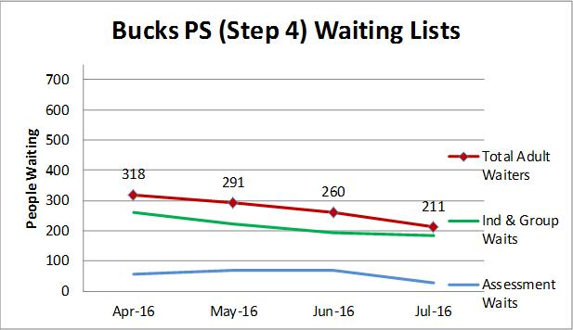  Oxfordshire recruited temporary staff to the City and North AMHTs. However, these staff have since left or are planning to leave shortly. Further potential agency recruits are being jointly reviewed and further interviews for CBT staff are planned in September 2016. Meanwhile, the number of people waiting for therapy are falling.  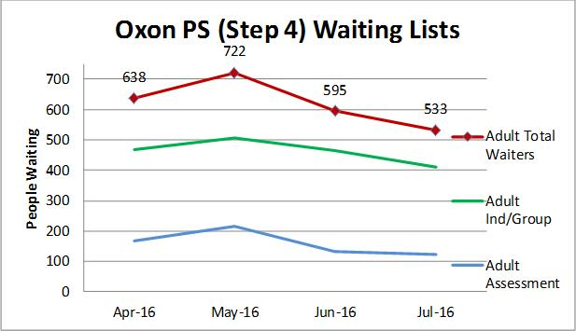
4.10 | The Oxfordshire Mental Health Partnership will be introducing a single point of access in 2016 for all patients accessing the six partnership organisations. | Adult | The single point of access is in place across the adult mental health teams and the third sector partners are in the process of integrating into this approach. There are already Connection, Restore and Mind workers working within the adult community mental health teams, which is proving to be very effective. Work is in progress for Mind Wellbeing service to work into the day hospitals.  The integration of peer support workers across the partnership is progressing, and the apprentices have now joined several of the teams across the partnership, all of whom have been paired with a mentor to support them in their roles.  The organisations which make up the Oxfordshire Mental Health Partnership are starting to collate information to evaluate the impact after the first year, October 2015-October 2016.
4.11 | Unification of the current mental health services provided out of hours by bringing together the management to improve the urgent care mental health pathway for referrers, patients and staff.  Services; emergency department psychiatric services in Oxfordshire and the psychiatric in-reach liaison service in Buckinghamshire, the street triage teams in both counties, the night teams in both counties and the South Central Ambulance Service mental health controller working in the 111/999 call centre. | Adult | Update to be provided in Q2.
4.12 | Patient flow and development of the bed management system to ensure timely admission and discharge | Adult | In the context of challenging bed pressures within the trust and nationally managing patient flow becomes even more important. The Directorate is carrying out the following re-design work at the moment with partners.  Housing & ward redesign;  The purpose of this work is to achieve the following outcomes: people to continue to live in stable accommodation and people will improve their level of functioning. Activity is progressing well to achieve these outcomes:  - The Right Time Right Place project aims to improve patient flow through daily discussions between wards and community teams using a consistent approach to measure patient progress, five days a week. This is being piloted in Buckinghamshire and will be rolled out across Oxfordshire in Q2.  - Alternative accommodation provision delivered by the third sector to provide suitable accommodation to meet the needs of service users that do not require acute inpatient beds is under design, and a business case will be produced by 30th October 2016.  The trust continues to monitor delays and out of area placements, details below.  Delayed transfer of care  The number of mental health delayed transfers of care remains low at 1.4% in April 16, 2.7% in May 16 and 1.7% in June 2016; this is against a national target of less than 7.5%. In June 2016 there were 11 different patients delayed across adults and older people mental health wards.  Out of area placements  Below is a summary of the out of area placements from adult and older adult mental health wards due to demand and capacity from April 2016 (this excludes out of area specialist placements as clinically appropriate). For patients still out at the time of this report, the number of days has been calculated up until 30th June 2016.
4.13 | Improving productivity & retaining quality in community and district nursing | Older People | We are working with Newton Europe and Oxfordshire Clinical Commissioning Group on improving quality in the district nursing and specialist community nursing services, e.g. diabetes; tissue viability; end of life community matrons; heart failure and core respiratory. The overall aim of the project is to maximise efficiencies and measure the opportunities to release clinical time to care within the District Nursing Service, by standardising methods and processes, piloting, reviewing, and implementing the improvements identified as part of the Newton Europe District Nursing review. Work includes standardising handovers, caseload review, reducing travel time, standardising clinical pathway, introducing district nurse duty desk and co-locating district nursing teams into larger teams.  The work completed so far by work stream is;  Standardising Handovers  - SOP implemented in 6 pilot teams  - Collated baseline data and measured data against the baseline in 6 pilot teams  - Carried out staff benefit review and incident review  - Completed a review of the pilot teams and continue to pilot based on findings  - Dates to implement the SOP across all DN teams has been submitted  Caseload Review  - Implemented SOP in 3 pilot teams and measured baseline data  - Completed first review of the pilot teams & continue to pilot based on findings  - Collated data that we are able to analyse throughout the pilots  - Staff surveys completed as part of the evaluation  Standardising Pathways  - Agreed approach and sub-team established  - Launched audit in May 2016 for patients on the aetiology pathway  - Started to gather results from DN teams for analysis  - Training programme in place  Starting from Home  - Completed 3 table top exercises with Horsefair team in Banbury  - Learning from Faringdon team who already have a starting from home method  - Contacted Gloucester and Coventry Trusts to understand how this is managed  - Discussions with IT to carry out an options appraisal for technology to support starting from home  Duty Desks  - Completed evaluation on first Duty Desks to go live in West and South West  - Established a sub group  - Chipping Norton piloting a Duty Desk as part of the Out of Hospital Nursing project  - Central locality started pilot  - Reporting template in place across all ‘live’ duty desks
4.14 | Implementing a new outpatient ambulatory care clinic and service 7 days a week for South East Oxfordshire patients | Older People | The Rapid Access Care Unit project team continues to work with subject matter experts, partners from Royal Berkshire NHS Foundation Trust and local stakeholders to develop the innovative and integrated systems and processes to support the delivery of an ambulatory service by an integrated, multidisciplinary team with access to intermediate care beds for Henley-On-Thames and the surrounding areas. The service is expected to commence in October 2016.
4.15 | Achieving & maintaining accreditation for each of the mental health services (memory services and older people wards) | Older People | AIMS:  The starter forms are complete and have been submitted and the full self-assessments were completed at the end of July 2016. All three inspections are to take place throughout August/ Sept 2016.  MSNAP:  All the memory clinics obtained accreditation as follows in 2015/16:  • South Bucks: accredited  • North Bucks: excellent  • South Oxon: excellent  • Central Oxon: excellent  • North Oxon: accredited  A working group of all relevant parties and all CMHT's are meeting and reviewing current position against all standards to ensure accreditation is maintained.
4.16 | Improving inpatient identification & management of depression in older people mental health wards | Older People | The following actions have been taken so far;  - Depression assessment tool identified Montgomery and Asberg Depression Rating Scale (MADRS).  - Tool rolled out and in use across all mental health older people wards.  - Baseline audit has been completed, results below.  Baseline audit results;  - Has the patient got depression – Yes 44%  - Was the depression tool used on admission within 72 hours– Yes 8%  - Was the depression tool used again on discharge or 2 weeks later if applicable – Yes 9%  Actions following the baseline audit to be agreed.

The training will exclude covering the use of restrictive practice as this is not appropriate for a community based staff.

